

AHU CONTROLLER TEST DATA SHEET

P/N: 413-8005-2-63 Date: 11/04/2018 Time: 16:10

S/N: 287 Tested by: s

Hardware Rev: BLDC_60A_V6 Approved by: s

Software Rev: 5.3.9

Tester Software Version: 1.2j

Equipments Used

Equipments Model No Serial No

Power Supply

Digital Multimeter

CAN Interface

Resistance Decade Box

PC

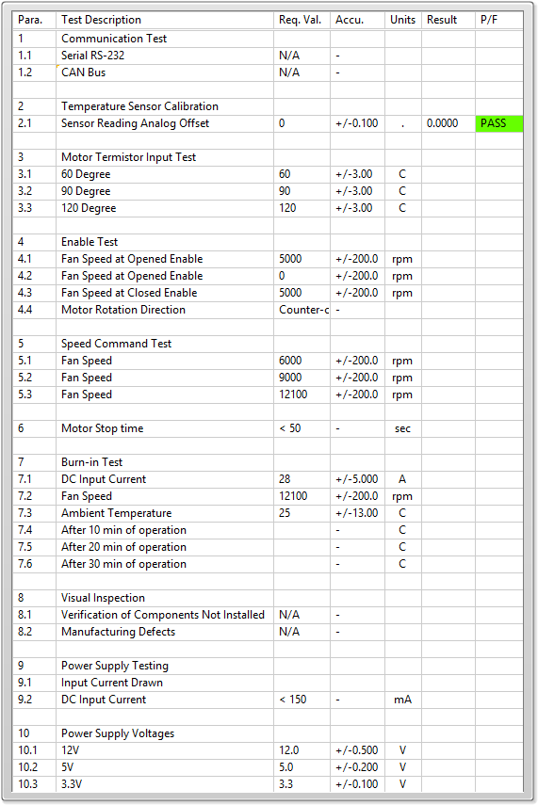

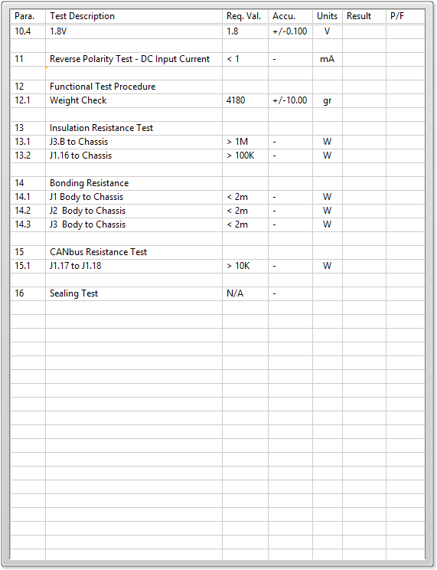

General result:

Test-Operator:____ s_________ Q.A.:__________________________